TASK:11 GAME PLAYING
Date:24.10.25

CO1, CO2, CO3

PROBLEM STATEMENT :

Game playing is a classic domain in Artificial Intelligence where an intelligent agent must make decisions to achieve the best possible outcome in a competitive environment. The goal is to design an AI system that can play a game against a human or another computer by analyzing the game state, predicting future moves, and selecting optimal strategies.
The problem involves developing an intelligent game-playing agent capable of reasoning, planning, and adapting its moves using algorithms such as Minimax, Alpha-Beta Pruning, or Reinforcement Learning. The system must evaluate possible future states of the game, consider the opponent’s potential moves, and make decisions that maximize its chances of winning.

AIM:
The aim of playing a game is to achieve a specific objective or goal by following the rules, using skill, strategy, or chance—while having fun and often learning or socializing in the process.

OBJECTIVE:
- To model the game environment using defined rules and valid moves.
- To implement search strategies (like Minimax, Alpha-Beta Pruning) to determine the best move.
- To evaluate game states using heuristic functions.
- To enable the system to handle both deterministic and non-deterministic outcomes.
- To simulate human-like decision-making for competitive or cooperative play.
- To test and optimize the performance of the AI agent for different difficulty levels.

DESCRIPTION:
Game playing in Artificial Intelligence refers to the development of computer programs that can play games intelligently against human players or other computer programs. A game-playing system analyzes the current game state, predicts possible future moves, and selects the most optimal action to achieve victory.
The system operates in a defined environment with specific rules, players, actions, and outcomes. It uses search algorithms such as Minimax and Alpha- Beta pruning to explore different game states and evaluate the best possible moves.
In more complex games, heuristic functions and learning techniques are used to improve decision-making and adapt strategies dynamically.
This concept is widely applied in games like Chess, Tic-Tac-Toe, Checkers, and Go, where the goal is to create an agent capable of reasoning, predicting, and competing effectively.

ALGORITHM:
Step 1: Start
Initialize the game board with the current state. Step 2: Check for Terminal State
If the game is over (win, lose, or draw), return the utility value:
+1 → if AI wins
–1 → if opponent wins 0 → if draw
Step 3: Generate Possible Moves
List all possible moves (actions) the current player can make. Step 4: Apply the Minimax Decision Rule
If it’s the AI’s turn (Maximizer):
For each move, simulate the move and call the Minimax function recursively. Choose the move with the maximum evaluation value.
If it’s the Opponent’s turn (Minimizer):
For each move, simulate the move and call the Minimax function recursively.Choose the move with the minimum evaluation value.
Step 5: Backtrack and Return Best MoveContinue recursion until the initial state. Return the move that gives the best value for the AI player.
Step 6: End

PROGRAM:
import math board = [
['X', 'O', 'X'],
['O', 'O', '-'],
['-', 'X', '-']
] def print_board(board): for row in board:
print(row)

def is_moves_left(board): for row in board:
if '-' in row: return True
return False
def evaluate(board): for row in range(3):
if board[row][0] == board[row][1] == board[row][2] and board[row][0] ! if board[row][0] == 'X':
return 10 else:
return -10 for col in range(3):
if board[0][col] == board[1][col] == board[2][col] and board[0][col] != '-': if board[0][col] == 'X':
return 10 else:
return -10
if board[0][0] == board[1][1] == board[2][2] and board[0][0] != '-': return 10 if board[0][0] == 'X' else -10
if board[0][2] == board[1][1] == board[2][0] and board[0][2] != '-': return 10 if board[0][2] == 'X' else -10
return 0
def minimax(board, depth, isMaximizing): score = evaluate(board)
if score == 10:
return score - depth if score == -10:
return score + depth
if not is_moves_left(board): return 0
if isMaximizing:
best = -math.inf

for i in range(3): for j in range(3):
if board[i][j] == '-':
board[i][j] = 'X'
best = max(best, minimax(board, depth + 1, False)) board[i][j] = '-'
return best else:
best = math.inf for i in range(3):
for j in range(3):
if board[i][j] == '-':
board[i][j] = 'O'
best = min(best, minimax(board, depth + 1, True)) board[i][j] = '-'
return best
def find_best_move(board): best_val = -math.inf best_move = (-1, -1)
for i in range(3): for j in range(3):
if board[i][j] == '-':
board[i][j] = 'X'
move_val = minimax(board, 0, False) board[i][j] = '-'
if move_val > best_val: best_move = (i, j) best_val = move_val return best_move
print("Current Board:") print_board(board)
best_move = find_best_move(board)

print("The Optimal Move for AI (X) is: Row =", best_move[0], "Col =", best_move[1])

OUTPUT:

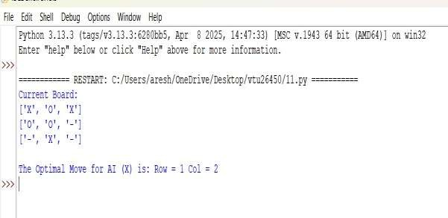

CONCLUSION:
Game playing is more than just a form of entertainment — it encourages learning, creativity, teamwork, strategic thinking, and emotional development. Whether played for fun, education, or competition, games play an important role in developing skills, building relationships, and providing enjoyment across all ages.

